Lauren Blatchford
Kelly Kolb
Justin Saunders
Hayley Stuber
David Johnson
Deliverable #3 - "Software Design Specification Document" Outline
- Introduction
  - Purpose of this document
    - To go over the overall design of the product and record any of the changes that have taken place during previous phases.
  - Any changes to previous plan
    - No changes

- Architectural Design
  - Two levels of abstraction
    - High
      - The UI interacts with the different pages of the application, which add movies to the browsing page, the movie info pages, the login page, the registration page, the administration page, and the customer account pages. The customers will only be able to interact with the pages that have been displayed through the UI. While the login and registration pages need to be able to interact with the customer database, and the browsing pages and movie info pages will have to be able to interact with the movie database. The administration page will interact with the movie database and the customer database.
    - Low
      - Adding details, adding search options and functionality, adding movies to the database, adding customers to the customers table. Creating a banner for the UI and image buttons.

- User Interface Design
  - Updated input screens
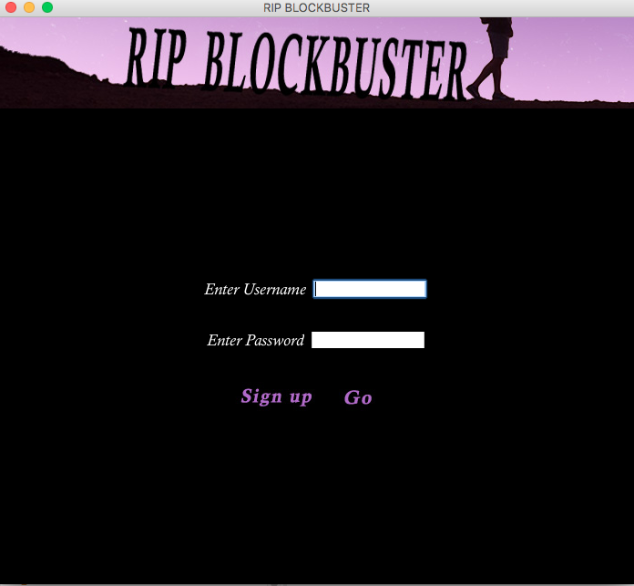
  - Updated output screens
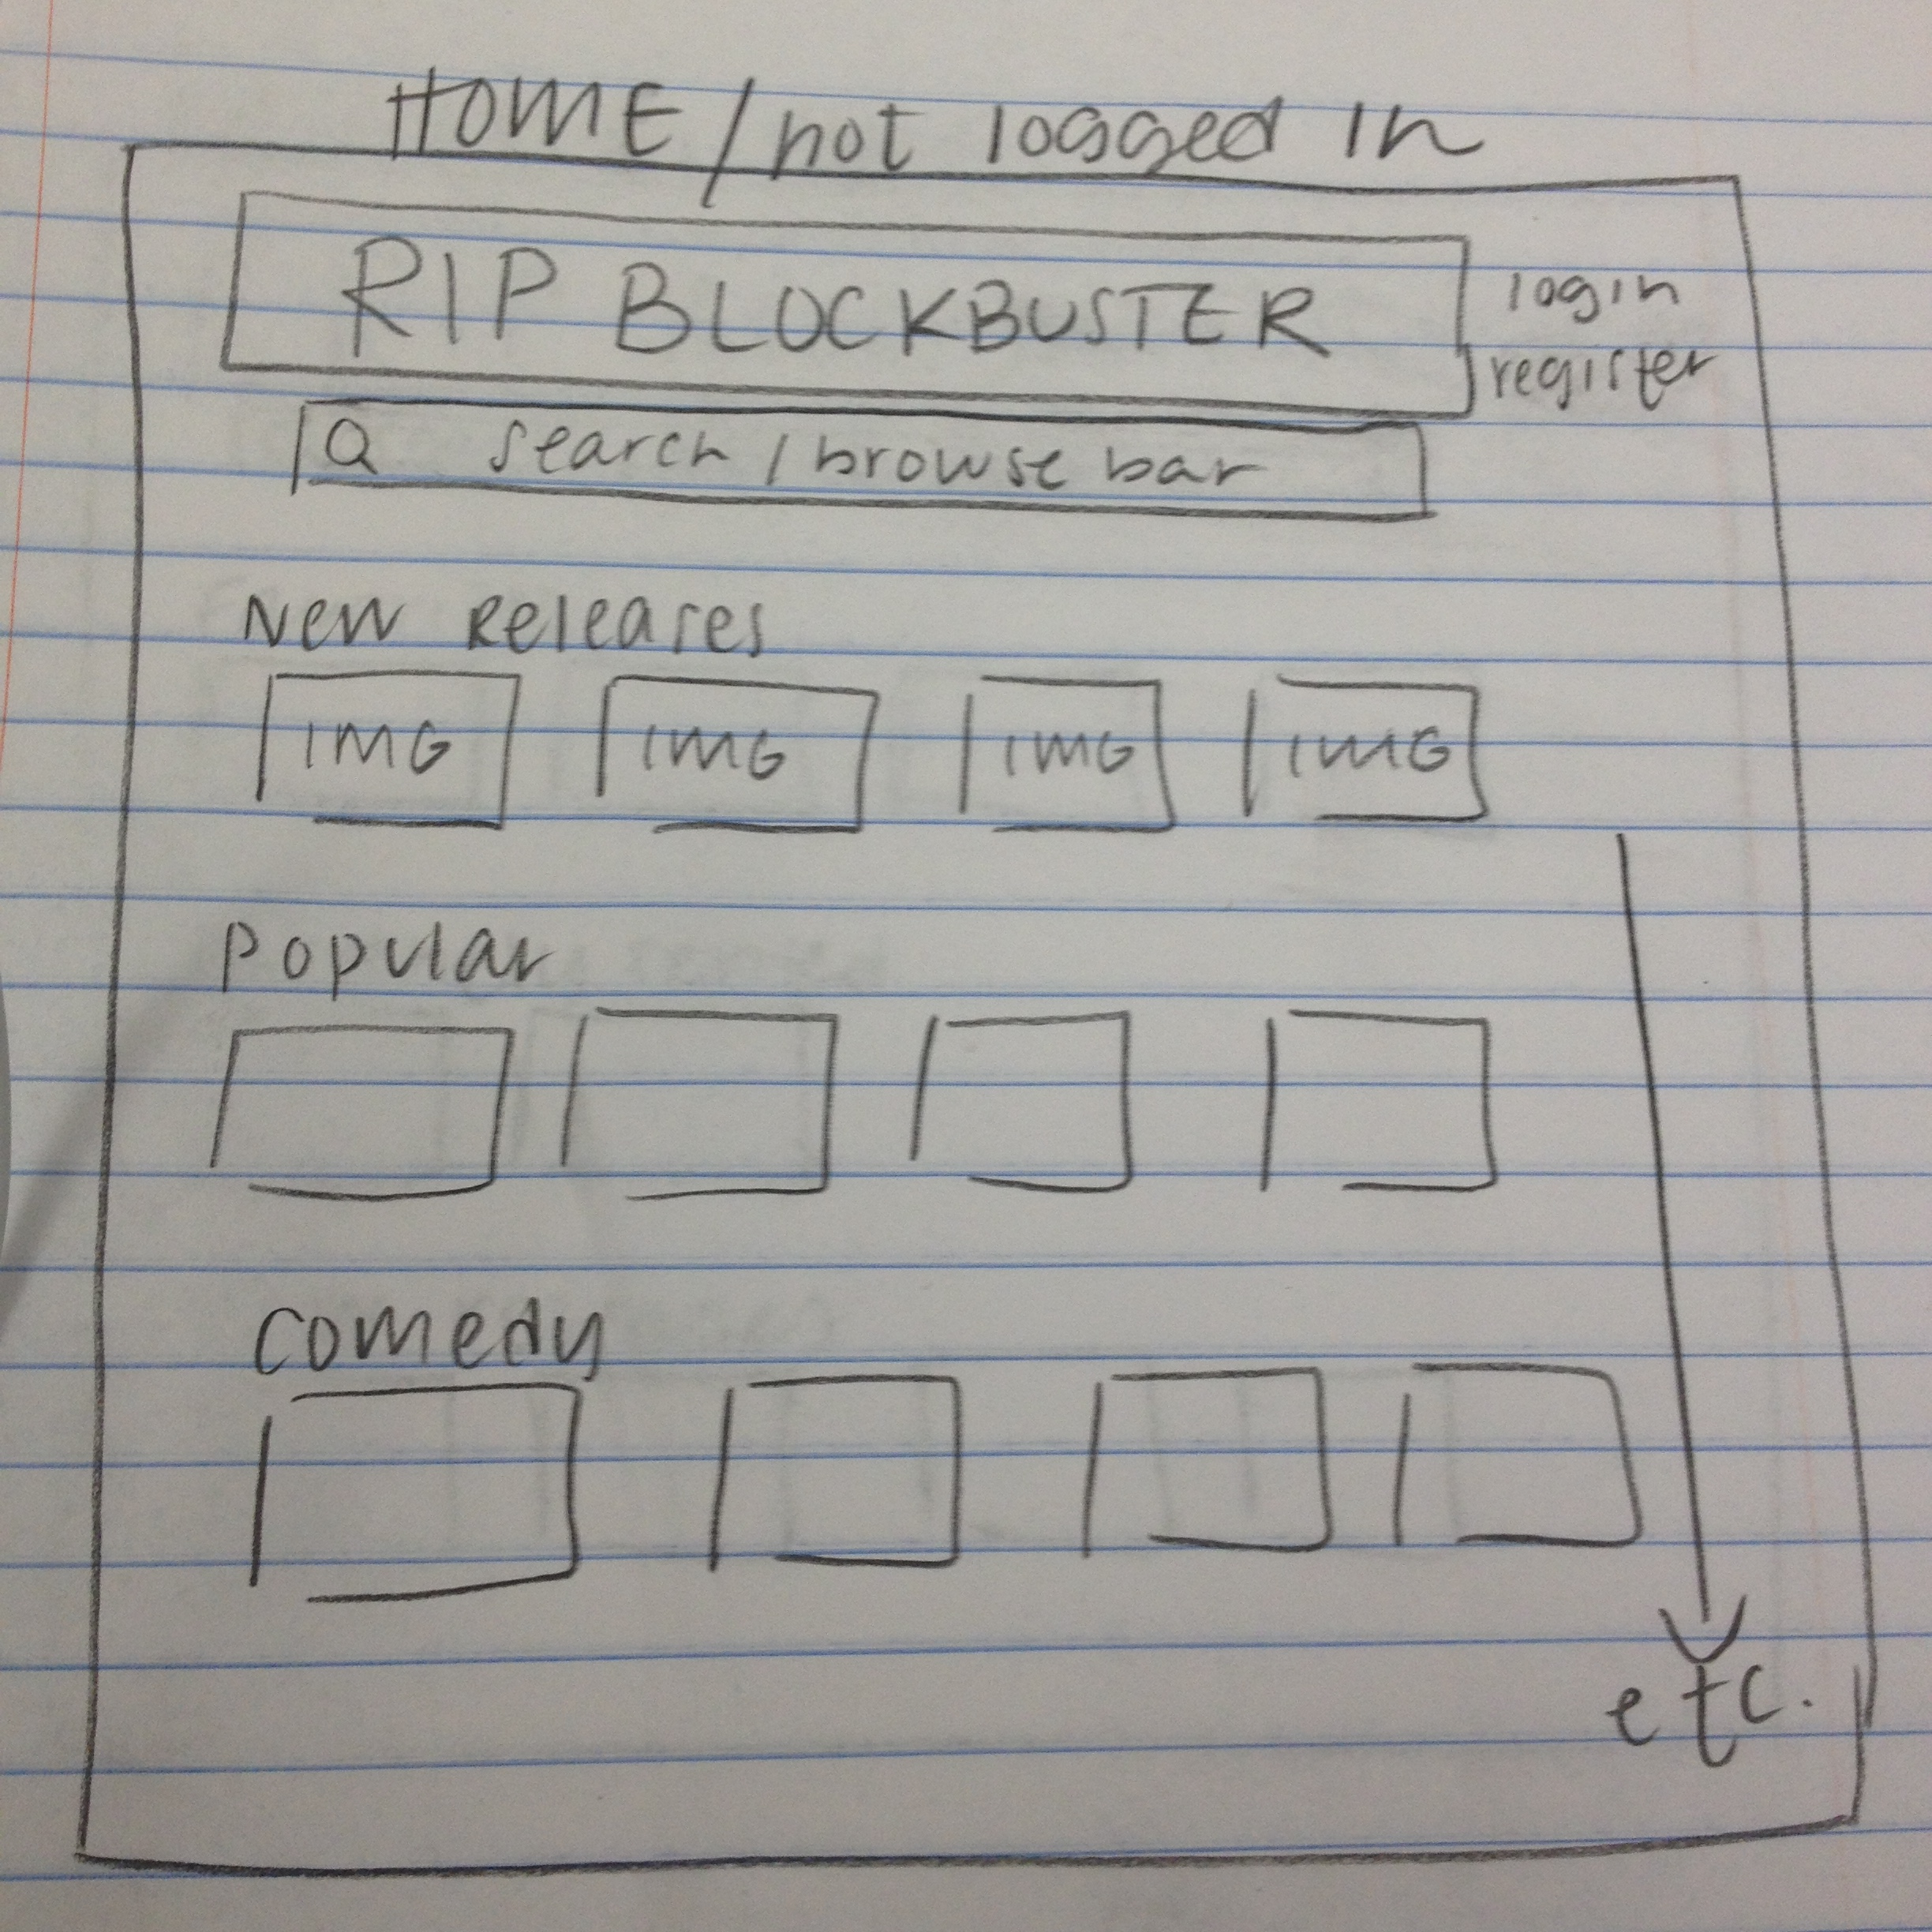

- Component Design (for each module)
  - Processing Narrative / Flowchart

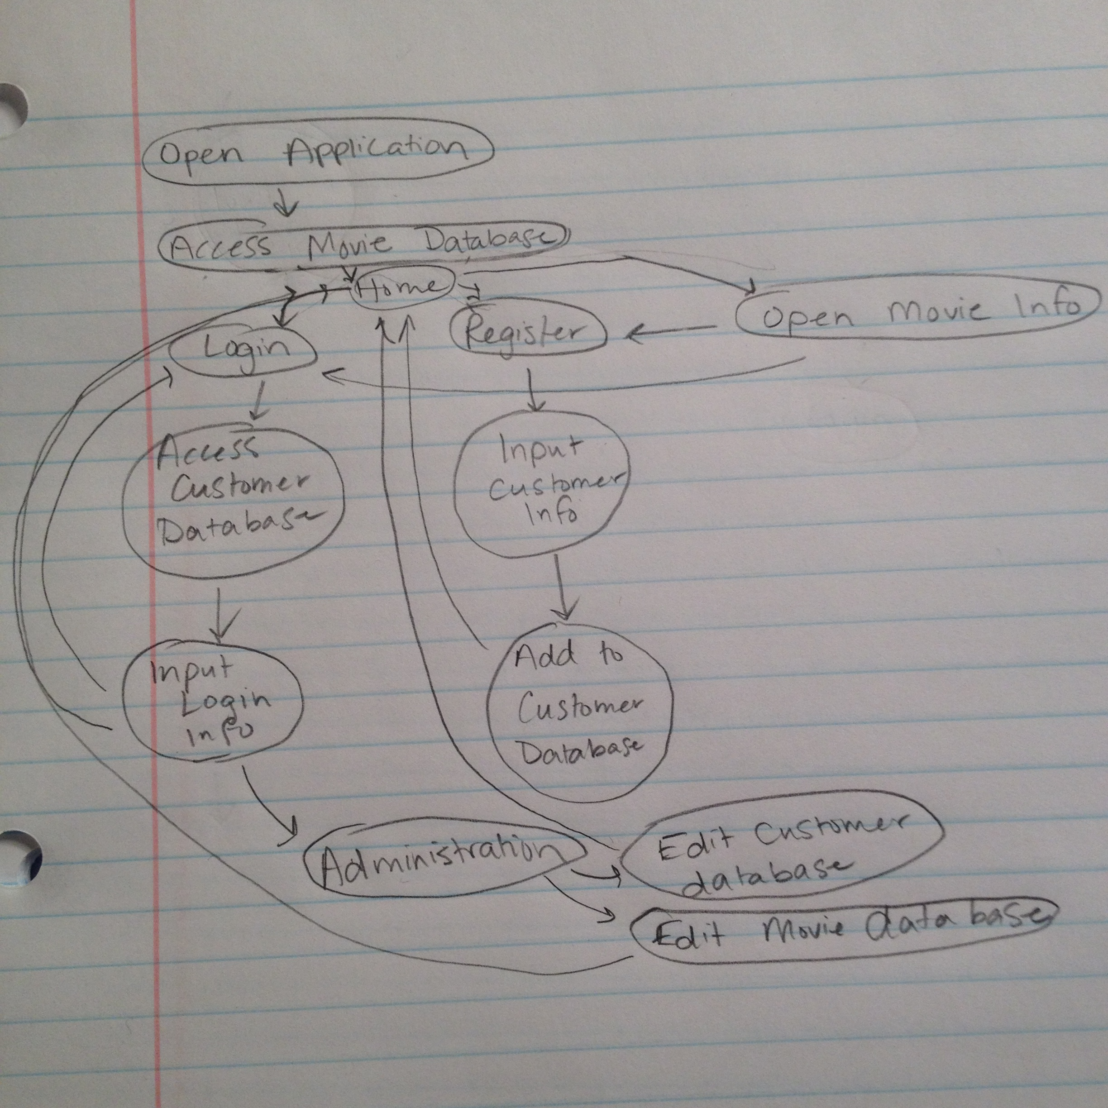
  - Interface Description
The interface will originally bring you to the home screen, which allows you to login, register, or browse movies. On the home screen, there will also be listed new releases and popular movies that have been rented. They will also be able to access a browse all page, which will bring them to a list of all the movies that the store has in stock. Once someone registers and logs in, they can then rent movies, favorite movies, and view their account, which will let them edit their email and password, view their account balance, look at which movies they are currently renting, and look at their favorite movies. If an administration account logs in, they will then be able to look at the customers in the database who have signed up, and edit their account balance, and look at the movies in the database and add more movies, take out movies, or edit the movie information.

- Data Design
  - Updated Class diagrams
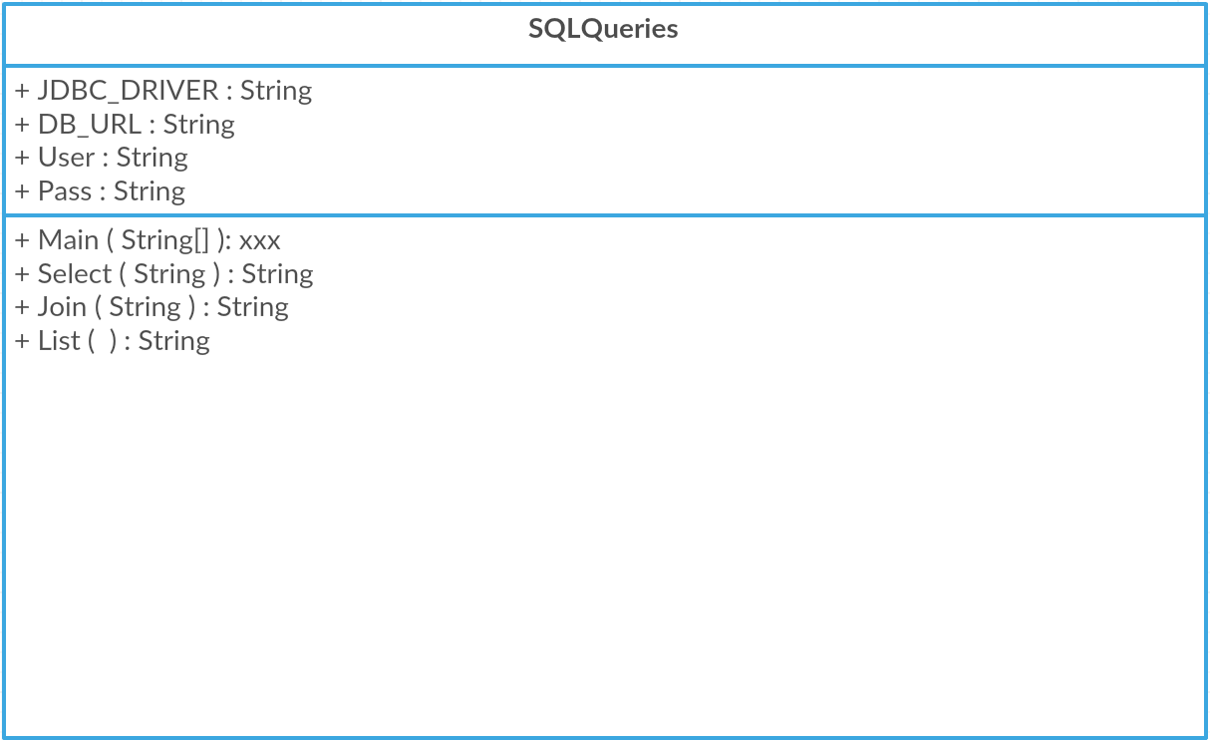

UI
+ frame: JFrame
+ bannerPanel: JPanel
+bannerLabel: JLabel
+banner: BufferedImage
+BANNER_WIDTH: int
+BANNER_HEIGHT: int
+create Frame()
+getFrame(): frame
updateFrame(JFrame, JPanel)

Login
+everythingPanel: JPanel
+usernamePanel: JPanel
+passwordPanel: JPanel
+buttonPanel: JPanel
+usernameLabel: JLabel
+passwordLabel: JLabel
+username: JTextField
+password: JTextField
+go: JButton
+signUp: JButton
+font: Font
+usernameborder: EmptyBorder
+passwordborder: EmptyBorder
+buttonborder: EmptyBorder
+Login()
+getPanel(): JPanel

Register
+everythingPanel: JPanel
+usernamePanel: JPanel
+passwordPanel: JPanel
+phonePanel: JPanel
+namePanel: JPanel
+buttonPanel: JPanel
+usernameLabel: JLabel
+passwordLabel: JLabel
+nameLabel: JLabel
+phoneLabel: JLabel
+username: JTextField
+password: JTextField
+phone: JTextField
+name: JTextField
+register: JButton
+font: Font
+usernameborder: EmptyBorder
+passwordborder: EmptyBorder
+buttonborder: EmptyBorder
+Register()
+getPanel(): JPanel

Home
+everythingPanel: JPanel
+search: JTextField
+go: JButton
+newReleasesLabel: JLabel
+popularLabel: JLabel
+newReleasesPanel: JPanel
+popularPanel: JPanel
+Home()
+getPanel(): JPanel

Movie
+everythingPanel: JPanel
+rl: String
+poster: BufferedImage
+title: String
+director: String
+genre: String
+actor: String
+rating: String
+available: String
+editUrlLabel: JLabel
+editUrl: JTextBox
+editTitleLabel: JLabel
+editTitle: JTextBox
+editDirectorLabel: JLabel
+editDirector: JTextBox
+editGenreLabel: JLabel
+editGenre: JTextBox
+editActorLabel: JLabel
+editActor: JTextBox
+editRatingLabel: JLabel
+editRating: JTextBox
+editAvailableLabel: JLabel
+editAvailable: JTextBox
+Movie()
+getUrl(): String
+setUrl()
+getTitle(): String
+setTitle()
+getdDrector(): String
+setDirector()
+getGenre(): String
+setGenre()
+getActor(): String
+setActor()
+getRating(): String
+setRating()
+getAvailable(): String
+setAvailable()
+getCustomerPanel(): JPanel
+getAdminPanel(); JPanel

Browse
+everythingPanel: JPanel
+search: JTextbox
+go: JButton
+allmovies: JLabel
+allmoviesPanel: JPanel
+moviesList: JPanel
+Browse()
+getPanel(): JPanel

UserAccount
+everythingPanel: JPanel
+name: String
+email: String
+password: String
+fees: int
+favorites: ArrayList
+nameLabel: JLabel
+emailLabel: JLabel
+passwordLabel: JLabel
+feesLabel: JLabel
+editName: JTextField
+editEmail: JTextField
+editPassword: JTextField
+editNameGo: JButton
+editEmailGo: JButton
+editPasswordGo: JButton

+UserAccount()
+getName(): String
+getEmail(): String
+getPassword(): String
+getFavorites(): ArrayList
+getPanel(): JPanel

Administration
+everythingPanel: JPanel
+customerList: ArrayList
+movieList: ArrayList
+movie: Movie
+moviePanel: JPanel
+searchCustomer: JTextBox
+searchCustomerLabel: JLabel
+searchMovie: JTextBox
+searchMovieLabel: JTextBox
+Administration()
+getCustomerInfo(): String
+editCustomerInfo(String)
+getMovieInfo()
+editMovieInfo(String)
+getPanel(): JPanel

  - Data dictionary

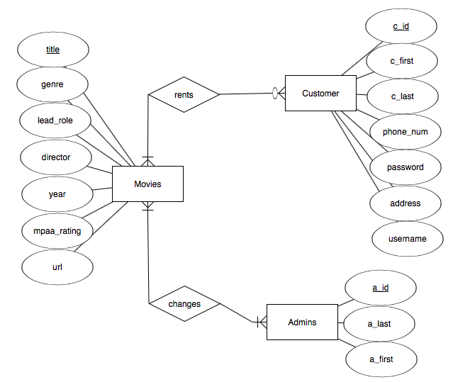
  - Updated ERDs

- Change Request Form
--Other File—

- Test Plan
1.0 INTRODUCTION

The product being tested is a video rental platform for brick-and-mortar stores. In contrast with streaming services, this program will be used to control a physical inventory of films, customer rentals, and host a dynamic search to allow users to find the movies they want easily.

2.0 OBJECTIVES

The objective of the test plan is primarily to document the integration between the SQL Database and the program itself. Customer rentals, admin updates, and searching all must interact with the database, making it the main focus of the test plan.

3.0 TESTING STRATEGY

The programming has been broken into 3 major sections, First, integrating the database into Java, in order to run queries and display the information in the program. Second is account creation and management for both customers and the admin. Finally, the search function for users to easily find the films they want or explore genres for new films.

To test the database integration, we are testing the different items for each database entry and sorting films in these categories. These include titles, genres, actors, and more. Being able to query the database for this information is essential for this program.

Sample user accounts are being made to test logging in, managing past rentals, and payment options. This data is manually set for testing, so it does not reflect actual interaction with the database of films. By accessing these dummy accounts in the program we can verify that this information is able to be manipulated.

The search function is being tested with lists unrelated to the database to verify that it can be updated automatically and with different sets of information. Once it is able to do so, it will be updated to do the same functionality with the database.

- Project Meeting Notes

- Movie table in SQL completed, data needs to be added into customer table and admins table
- Can dynamically search through documents, needs to be joined with other components in the project and made functional with SQL
- Continuing to debug the code to connect Java and SQL
- Added homepage and browse to the UIs

